

CS259 Project

Guided By – Prof. Samrat Mondal



Group Members:

Kalpit Agrawal - 2101CS34

Munesh Meena - 2101CS47

Praveen Kumar - 2101CS61

**TPC Database Design**



**ER Diagram**

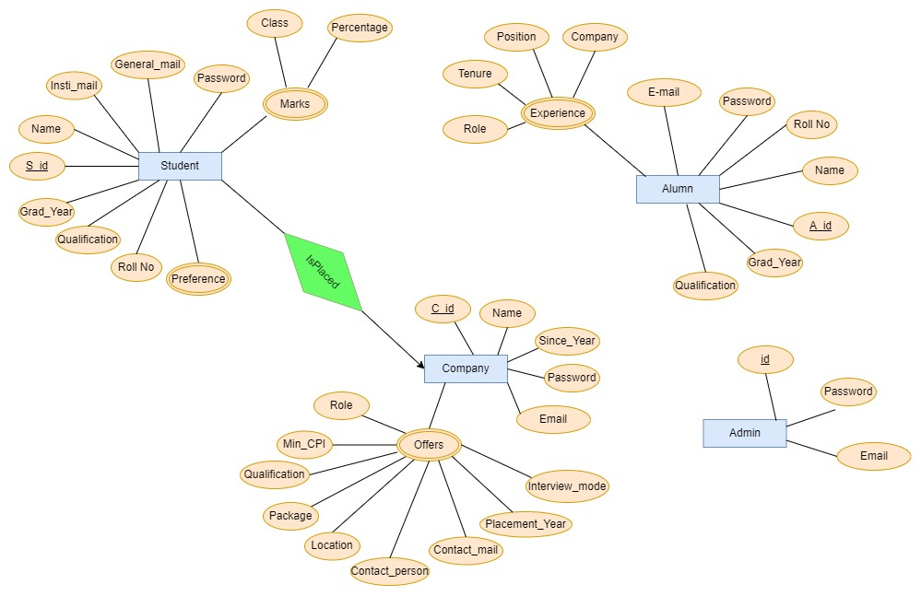

**Tables and Description**

The below diagram shows all the tables used in this section along with respective primary keys and foreign keys:

* **Student Entity**: To store all details of the Student entity we need have created four tables.
  + **Student_database** **:** It contains all the basic information of the student. It is linked to all the other tables that contains any info related to a student.
  + **Student_auth :** It contains all the login/authentication details of the current students.
  + **Student_marks :** From ER diagram, as we can see marks is multivalued. Hence, we have created another table to store the information related to marks.
  + **Student_pref :** It contains the job roles preferred by students so that they can effectively search the companies they are interested in and companies can also get an overview of the pool students.
* **Company Entity:** To store all details of the Company entity we need have created three tables.
  + **Company_database :** It containsall the basic information related to the company. It is linked to all the other tables that contains any information related to the company.
  + **Company_auth :** It contains all the login/authentication details of the company.
  + **Company_roles :** As role is a multivalued attribute we have created an different table to store it. Table contains all the job offers given by the company. It also contains the contact person information of recruiter of that particular role.
* **Alumnus Entity:** To store all details of the Alumnus entity we need have created three tables
  + **Alumnus_database:** It contains all the basic information related to the Alumna. It is linked to all the other tables that contains any information related to the company. This information is directly transferred form the student database and is implemented using a trigger.
  + **Alumnus_auth:** It contains all the login/authentication details of the alumnus.
  + **Alumns_placed :** It contains record of the company alumnus has been. This data is choice of an alumnus to fill and is not mandatory.
* **Admin Entity:** Since it is pretty straightforward entity we have only one table for this entity.
  + **Admin_auth :** It contains all the login/authentication details of the admin.

** NOTE:** student_auth table contains email and student_database table too. This is done for security reasons. Once the authentication is done we don’t want to go back to that table so that password cannot be accessed from it. Hence, for better security we are allowing some redundancy in our database design.

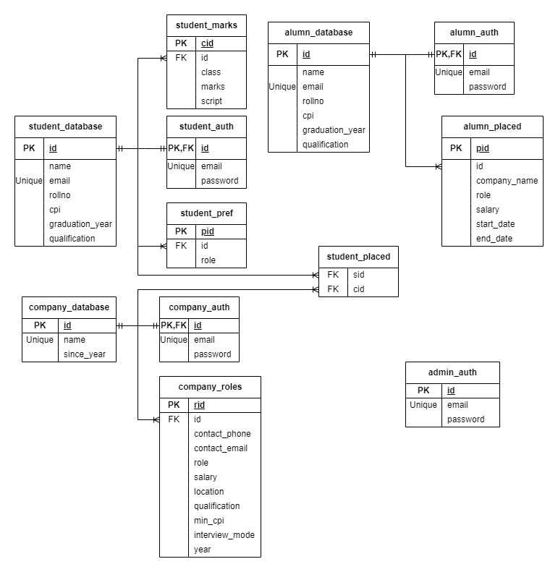

*Schematic representation of the database*

**Triggers**

To transfer data of student to the alumnus we have created two triggers

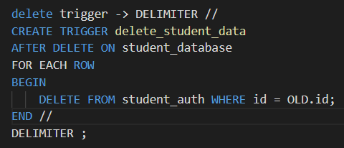

This deletes the data from the student tables. When a delete query is applied on student_database then after delete on this table we will trigger a delete on student_auth to delete authorization of the data.

This updates the alumnus tables with data from the student tables which satiesfies the criteria 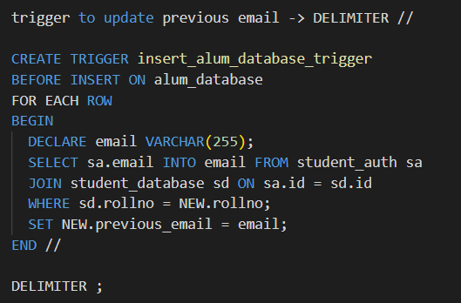,

What this trigger do is check wether rollno of new alumni registration is matching with the old student database, and if it is matching then getting the previous college email id of the student and setting it in alum_database previous_email.

**Websites and other works**

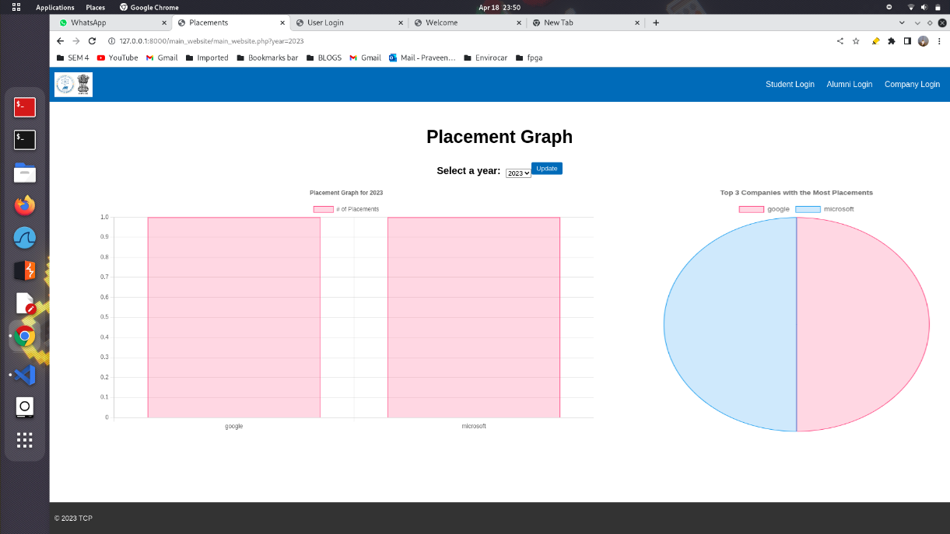

Main Page

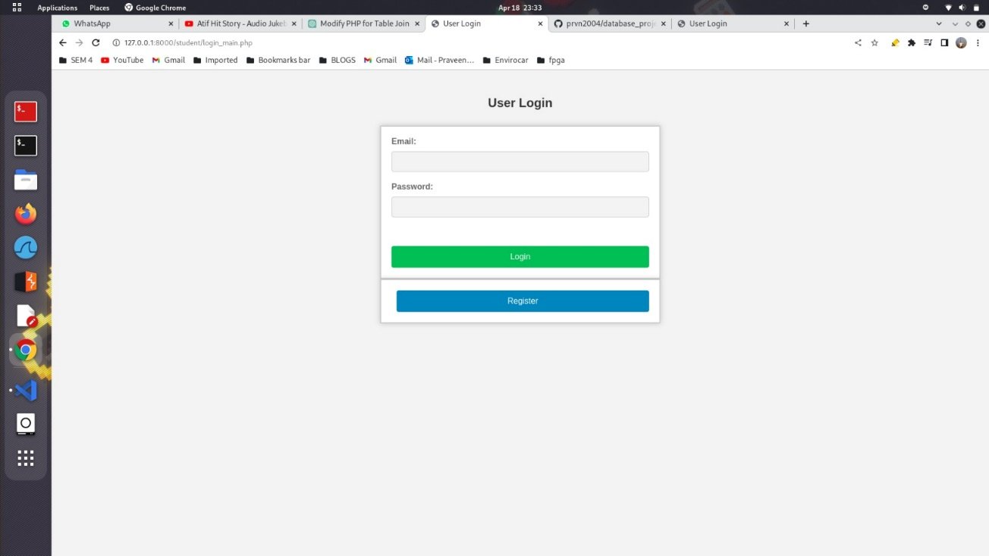

Student Login Page

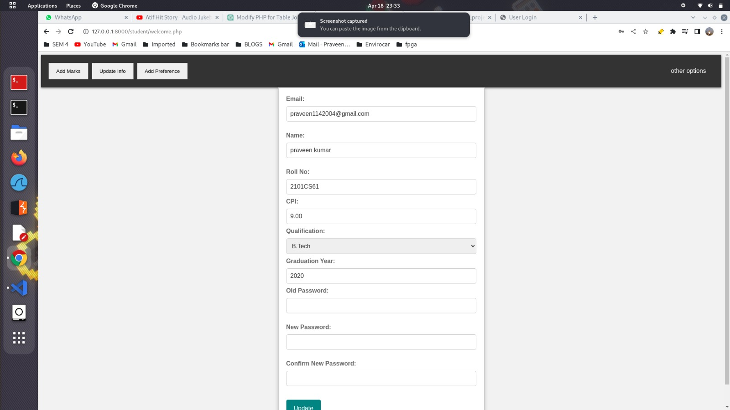

Student Registration Page

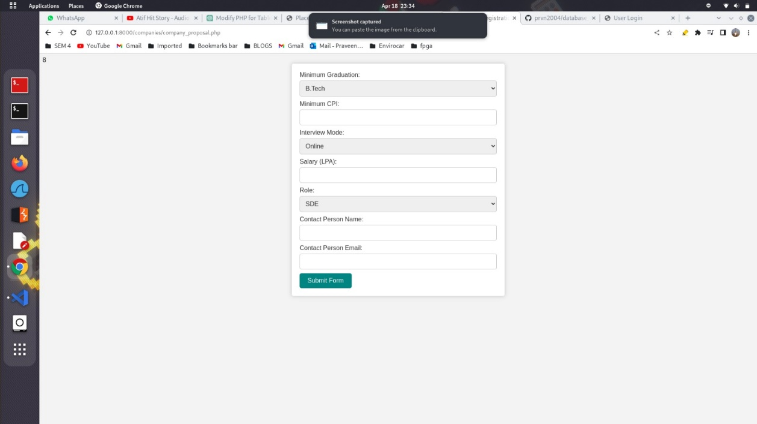

Company job offer page

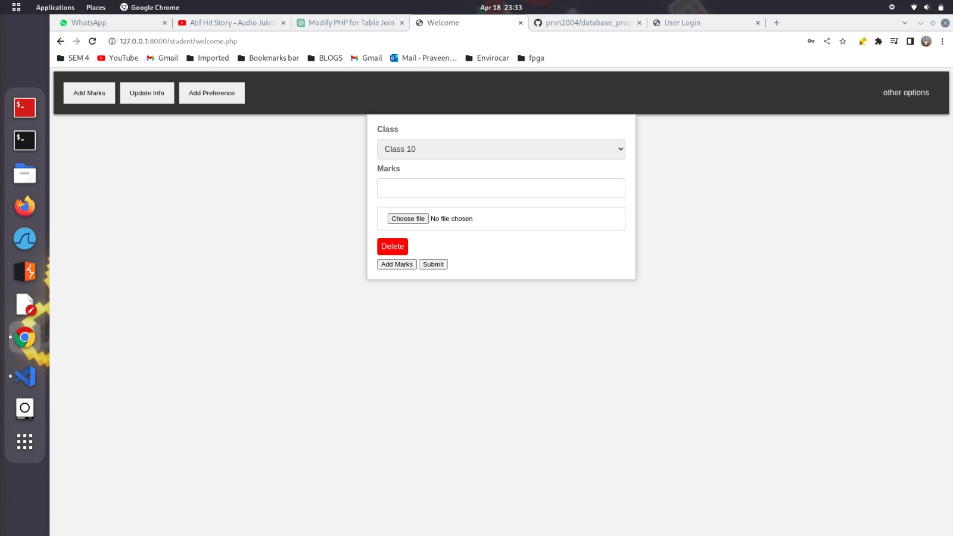

Marks Upload Page

Video: <https://drive.google.com/drive/folders/1K4z8ae2ijQ-9Rbh0WfrwouznAX-h7ZtZ?usp=sharing>

Code Repo: https://github.com/prvn2004/database_project